Ceng 435 – WireShark A ssignment 2

Muhammed Yusuf Temizer - e2099356

Answer 1:

SYN → Packet No : 10
Segment No: 0
Source Port = 48962
Destination Port = 80

SYN-ACK → Packet No : 11
Segment No: 0
Source Port = 80
Destination Port = 48962

ACK → Packet No : 10
Segment No: 0
Source Port = 49650
Destination Port = 80

Answer 2:

 | packet number | segment number | ACK packet number | ACKed data
1. TCP Packet | 26 | 6373 | 27 | 1448
2. TCP Packet | 28 | 7821 | 29 | 13032
3. TCP Packet | 35 | 20853 | 36 | 1448
4. TCP Packet | 37 | 22301 | 38 | 2896
5. TCP Packet | 39 | 25197 | 40 | 4344

Answer 3:

Sending time of the 26. Packet = 2.535004822
Receiving time of the 40. Packet = 2.550528237
Total time of image receiving request = Receiving time – Sending time

Total = 2.550528237 – 2.535004822 = 0,015523415 second

Graph : Round-Trip Time vs Time

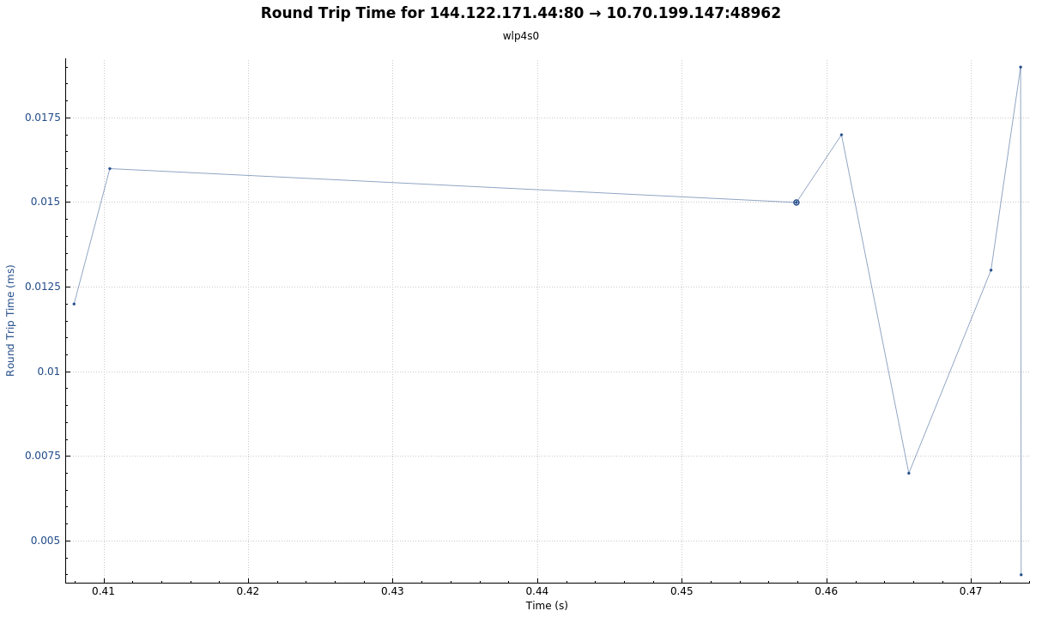
Answer 4:

No. There wasn’t any retransmission attempt while requesting the web page. After three-way handshake is done, color of the all the TCP packets are green until the last ACK packet is received.

